Lesson 6 – Websites

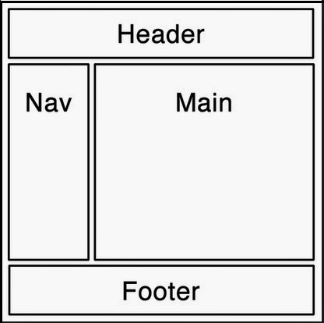**Task**:

- Create *a website* consisting of several *related webpages*.

- Use the *webpage* created on the previous lesson as a basic template ------>

- A content of individual webpages is up to you (examples are below).

- Make each webpage accessible from the navigation menu via its URL.

Recommended folder structure:

website [folder]

* index.html
* webpages [folder]
  + webpage1.html
  + webpage2.html
  + webpage3.html
* images [folder]
  + img1.jpeg
  + img2.gif
  + img4.png

Recommended content:

* *Header* with a title and logo of the website
* *Main page* (index.html) and 3 subpages (e.g. article, videos, game, contact...).
* *Navigation menu* as unordered list with links to individual webpages.
* *Subpages* with:
  + *Articles* according to your interest (i.e. from Wikipedia)
  + *Gallery* of images aligned in a matrix (using HTML table).
  + Embedded *video* or *game* (using iframe)
  + Contact *info*.
* *Footer* with a creation date, a name of the author and a copyright notice.

Validity check:

* Make all the webpages valid according to HTML5 standards - <https://validator.w3.org/>